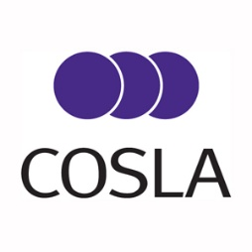

There will be a meeting of the COSLA Convention on Friday 25 February 2022 at 1200hrs via Microsoft Teams.

Sally Loudon
Chief Executive

AGENDA

Public Session
- Introduction from COSLA President
- Draft Minute of Previous Meeting of Convention on 26 November 2021 (paper)
- Revised COSLA Standing Orders and Scheme of Delegation (paper)
- Update on Incorporation of the European Charter of Local Self Government (paper)
- Scottish Local Government International Framework (paper)
- COSLA Budget 22/23 (paper)
- COSLA 5 year report: this is our story 2017-2022 (paper)
- COSLA Strategic Context and priorities post-election (paper)

